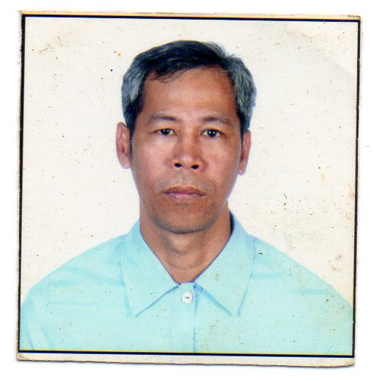

FERNANDO DELA CRUZ PINEDA
No. 636 Tawiran St. Panasahan
Malolos City, Bulacan
E- mail add: hudas132003@yahoo.com
Mobile no. 00639289821158

POSITION APPLIED FOR: Driller/ Assistant Driller

WORK EXPERIENCE:
Aug. 2010 to Mar. 2015 Parker Drilling Company
Driller
Papua New Guinea
Tesco Top drive 2000 HP

Feb 2010 to Aug. 2010 Nabors Brunei Rig 503
Driller/AD

2008 to Jan 2010 Transocean Offshore International Ventures Ltd.
Position : Assistant Driller

2007 TO 2008 Nabors Drilling International Ltd.
Position: Assistant Driller
Kuala Belait Brunei Darussalam
Rig 503 2500hp 3000mtrs
Canrig Topdrive Gas well drilling

2006 TO 2007 White Sands Petroleum Pty. Ltd
Position: Assistant Driller
Queensland, Australia
EDM Rig 1 1500hp 3000mtrs
National Topdrive Gas well drilling

2003 TO 2006 Nabors Drilling International Ltd.
Saudi Arabia
Rig 128 2500hp 17000ft
Canrig Topdrive Gas well drilling
Position: Assistant Driller

2000 TO 2003 Nabors Drilling International Ltd.
Position: Derrick Man
Saudi Arabia
Rig 656 Offshore 2500hp 16000ft
Canrig Topdrive Gas well drilling

1999 TO 2000 Kuwait Drilling Company
Position: Derrick Man
Kuwait

1989 TO 1993 Kuwait Drilling Company
Position: Roughneck
Kuwait

DUTIES AND RESPONSIBILITIES: AS A DRILLER

- Operate all equipment at the Driller’s console and on the rig floor in a safe manner and maintain a clean, organized, and hazard free condition on the drill floor and associated area.
- Monitor the well condition at all times (i.e. depth, mud weight, weight on bit, possible deviation from course et cetera). Interpret and respond to down hole conditions.
- Hold pre-job meeting with the drilling crew for all non-routine drilling operations.
- Supervise the lubrication and maintenance of all drilling and associated equipment and ensure it is carried out in accordance to the Preventive Maintenance System.
5 . Promote all company QHSE and other programs.

DUTIES AND RESPONSIBILITIES: AS AN ASSISTANT DRILLER

- In Charge in preparing tools for the certain HOLE OPERATION such as B.H.A. ( Bottom Hole Assembly ) Bit, Reamers ( Near Bit, Strings ) Cross – over jars, Shock sub, Drill Collars, Heavy Weights, Drill Pipes.
- Responsible for pipe tally, to help the Driller determine the depth where the bit is located. Assisting the Driller on computing the volume of the hole, string capacity, annular capacity and displacement.
- Preparing Casing tools for the next section like Spider Slips, Spider Elevators, Changing Jaws for proper sizes of the casing, Preparing for the right slips of segment of casing slip, Casing Bails, Single joint Elevators, Back – up and make up Tongs, Pup joint needed for the hole.
- Changing Pipe Rams, Dismantling and Installing B.O.P.’s. Assisting Tool pusher in testing Choke Manifold, supervise installing of flare line, also assigned to supervise on repairing reamers, replacing damage valve, valve seat, liners, pony rods, wear plates and modules of the Mud Pump.
- Assigned on both ONSHORE & OFFSHORE Rigs.

PERSONAL IDENTIFICATION:

Date of Birth : January 21, 1961
Place of Birth : Tondo Manila
Sex : Male
Civil Status : Married
Religion : Roman Catholic
Nationality : Filipino
Health : Excellent
Height : 5’9”
Weight : 70 kgs.

EDUCATIONAL BACKGROUND

PRIMARY : Panasahan Elementary School Graduated: 1975
Panasahan, Malolos City

SECONDARY : Marcelo H. Del Pilar High School Graduated: 1979
Sta. Isabel, Malolos City

TERTIARY : FEATI University
Course : Associate Marine Engineering

SEMINARS ATTENDED

BOSIET ADVANCE DRILLING PROGRAM

SEPTEMBER 2008 NOVEMBER 28 TO DECEMBER 28, 2008
SINGAPORE Transocean Training Center SINGAPORE

RIGGING & SLINGING CAP COURSE
AUGUST 03, 2007
BRUNEI DARUSSALAM

Bow Tie Training & workshop
MAY 20, 2007
BRUNEI

PERMIT TO WORK FOR SIGNATORIES
SEPTEMBER 11-12, 2007
BRUNEI

ALERT DISASTER CONTROL
BASIC WELL CONTROL
Date: August 20, 2000

BOP Maintenance
May 16 2009
Singapore
WELL CAP
Date: March 20, 2009
Singapore

MANAGING HAZARDS AT THE WORKPLACE
SEPTEMBER 10, 2007
BRUNEI

GAS TESTING
JUNE 18, 2007
BRUNEI

SENIOR FIRST AID
MAY 28-30, 2007
BRUNEI

COMPETENT WORKSITE SUPERVISOR
MAY 18-19, 2007
BRUNEI

IWCF Drillers Level
March 9, 2015

I hereby certify that the above information is true and correct through the best of my knowledge and beliefs.

Fernando Pineda
Applicant’s Signature

